**VLE AFTERNOON REVIEWS**

**TEACHER PROFILE**

**1.The delete button on learning materials is deleting all documents when you delete one document. - SOLVED**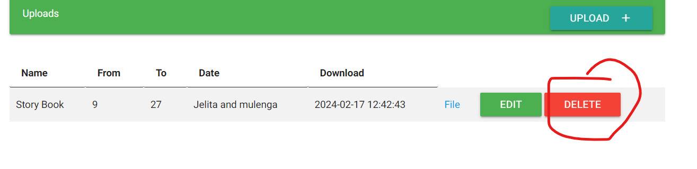

**2.Teacher cant edit assignment - Gift**

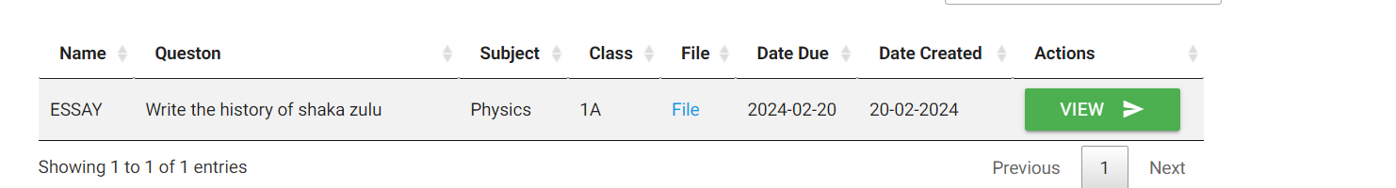

**3.On discusions I should be to able to delete/edit my discusions - Collins**

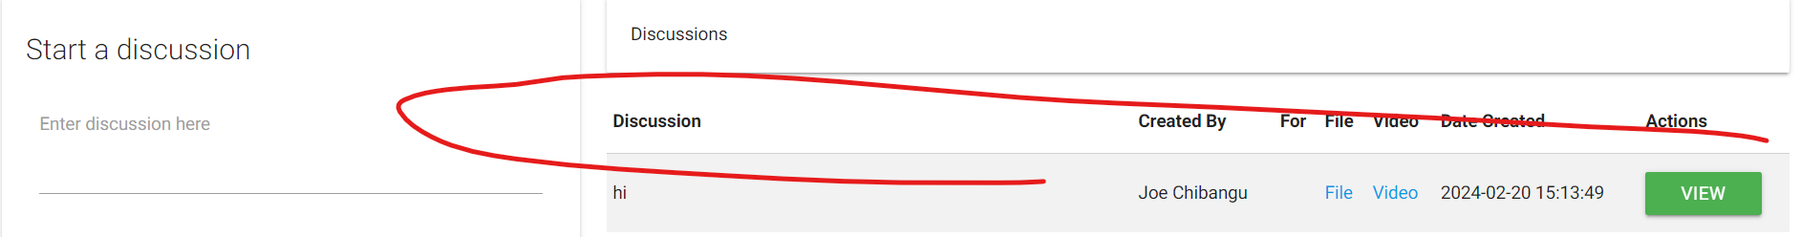

**ZOCS**

**1.On PTA notes it should show the name of the school were the complaint are coming from.**

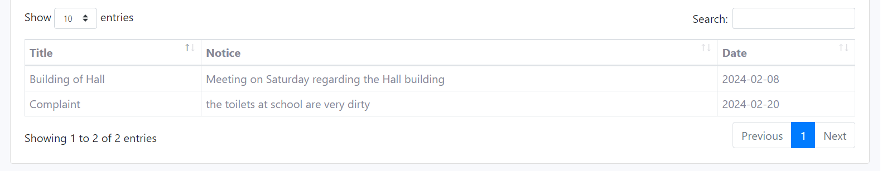

**2.Also on queries:it should show were the complaint is coming from**

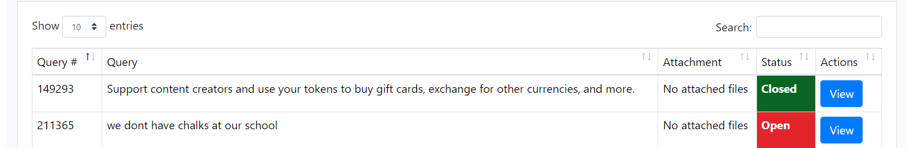

**3.E-document lets add edit also**

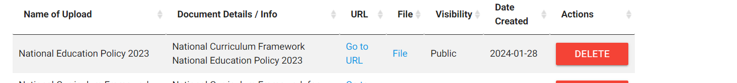

**STUDENT**

**1.Cant see the subject,my class and assignments**

**2024/zocs_gift/VLE/modules/functions/student/classes/view_class.php**

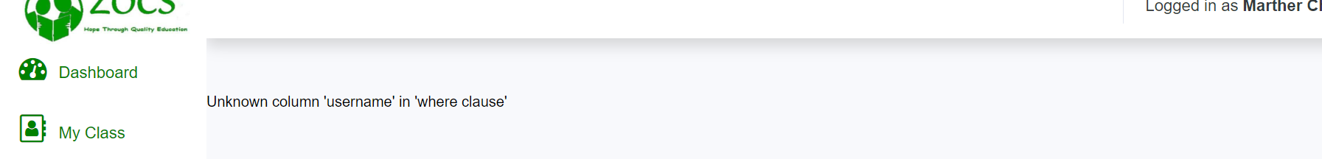

**2.I think learners should have accesss to learning materials too not just parent**

**1..check this on admin and parent**

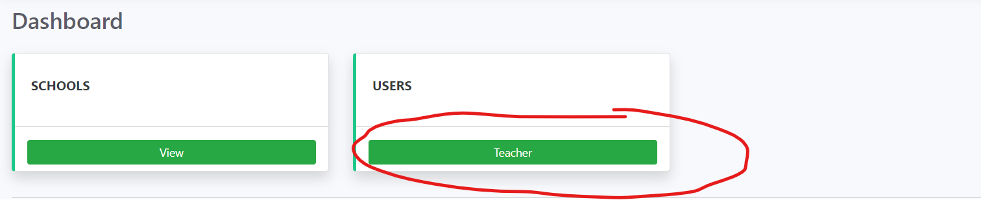

**2.all accounts to have blog page (view blogs)**

**3.When creating a learner let the teacher add the password not sending to email**